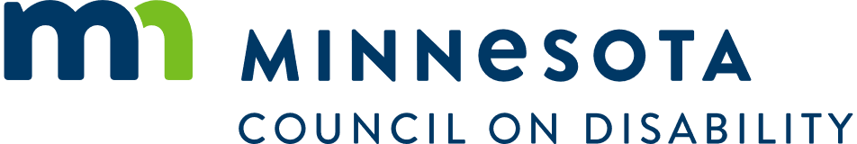

# MCD Access Workgroup Agenda

August 13, 2024  
10:00 am to 11:00 am  
Hybrid Meeting

Physical Location:  
Spruce Tree Conference Center  
1600 University Avenue West, St. Paul, MN 55104

Zoomgov link  
Join Meeting: [Zoomgov link](https://www.zoomgov.com/j/1601478715?pwd=V1lZVmlpS0luV3dsaHVpTXBYZ05RZz09)  
Meeting ID: 160 147 8715  
Passcode: 938236

## Agenda

* Open meeting – Chair
* Guest Speaker: Tammy Meehan Russell, GOMARTI
* Open discussion (what is happening in your area) – Everyone