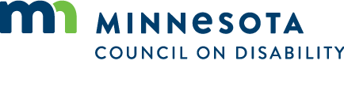

# Agenda: External Relationships Committee

11/21/2024  
1:00 to 3:00 pm

Spruce Tree Conference room, Rm 20  
1600 University Ave W, St Paul, MN 55104

Hybrid meeting. One member in person and all others may join via Zoomgov

Zoomgov Link: [Zoomgov Link](https://www.zoomgov.com/j/1603042676?pwd=sWn2oLIas3VdKyh8Sk96uMBQmQAH1h.1)  
Meeting ID: 160 304 2676  
Pass Code: 370134

## Agenda

### Open meeting

* Approve agenda November 21, 2024
* Approve minutes from March 21, 2024 (many meetings canceled due to lack of quorum)
* Identify presenters or stakeholders for March 10, 2025, June 20, 2025, September 10, 2025, and December 10, 2025, Full Council meetings.
* Adjourn – Chair